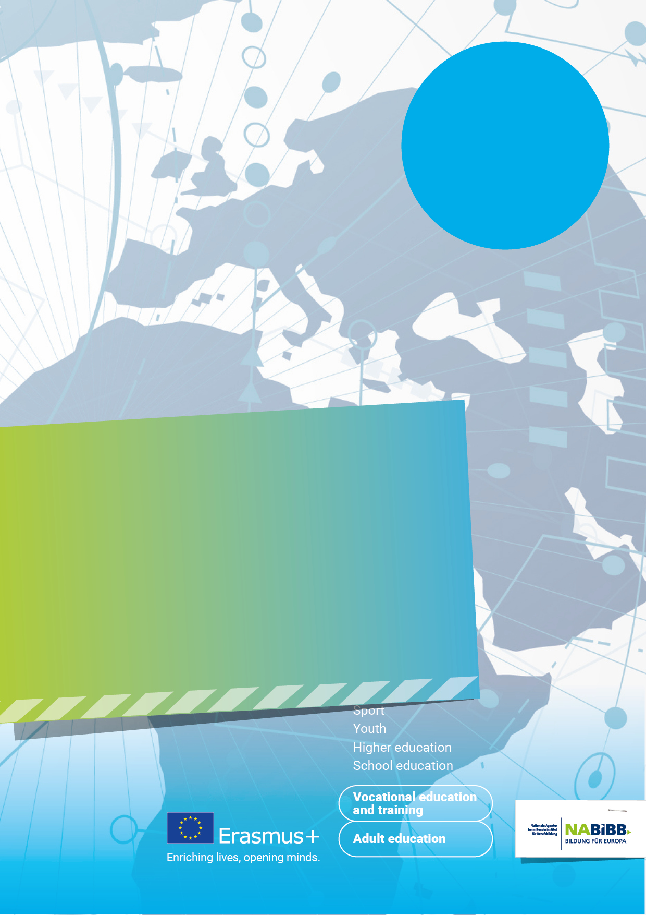
27.-29.05.2024
Learners Mobility
in KA 1

Training and Cooperation Activity

Adult Education - How to involve Learners
in KA1 projects

Blindtext Fachtagung am 01.01.2022 in Musterstadt


Venue
Kardinal Schulte Haus, Overrather Strasse 51-53
51429 Bergisch Gladbach (near Cologne)

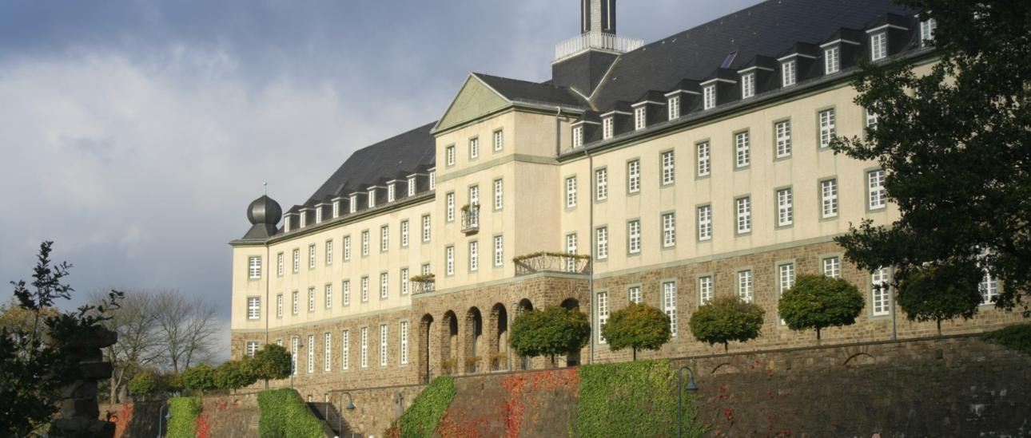

Moderator of the event: Paul Guest
You will receive support through:
NA at BIBB: Anke Dreesbach, Tanja Moeller, Ulrike Suckrau, Kerstin Bernhardt,

DAY 1 - Monday 27. May 2024

Until 14:00 | Individual arrival, registration and buffet lunch
15:00 | Welcome and Introduction
15:15 - 16:00 | Get to know each other
16:00 – 16:45 | Brief presentation of the Erasmus+ Programme Key Action 1
16:45 - 17:15 | Break
17:15 – 18:00 | Presentation of good practice on Learner involvement
18:00 – 19:00 | Break
19:00 | Dinner
From 20:00 | European Fair
22:00 | End of the first day of the Event

Day 2

9:00 - 9:30 | Start into the day & reflexion of day 1
9:30 - 10:45 | Impact+ Exercise part 2: exploring indicators  - Working groups
10:45 - 11:00 | Break
11:00 - 11:30 | Discussion on indicators & answering open questions
11:30 - 13:00 | Impact+ Exercise part 3: exploring data sources & data collection  - Input on part 3  - Working groups
13:00 - 14:00 | Lunch & informal networking

09:30 - 10:30 | Welcome and creative exercise
10:30 - 11:15 | Coffee Break
11:15 – 12:05 | Speed Dating
12:10 – 13:00 | Working Groups
13:00 - 14:00 | Lunch buffet
14:00 - 15:30 | Getting together of project partners
15:30 - 16:00 | Break
16:00 – 17:00 | Work on the project ideas
17:30 - 20:00 | Social event – Visit to Cologne
20:00 | Dinner in Cologne

DAY 3 - Friday 26. May 2023

09:30 – 11:00 | Welcome back / Energiser /  Work on the project ideas in groups
11:00 – 11:30 | Coffee Break
11:30 – 12:30 | Presentation of projects developed so far / Next steps
12:30 – 13:30 | Lunch buffet
13:30 | End of the event

DAY 2 - Tuesday 28. May 2024

