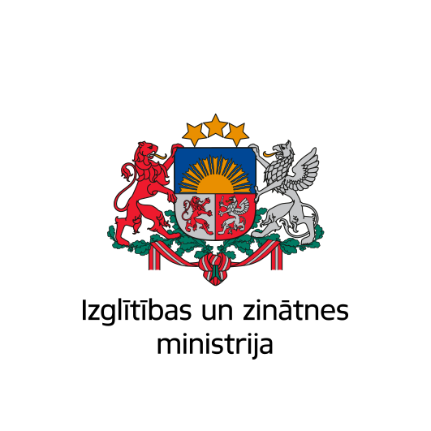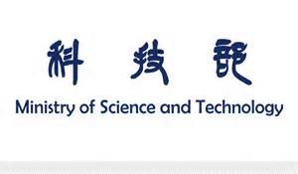

Mutual Funds
LatviaN - LithuaniaN-Taiwanese

Cooperation Project APPLICATION

Year 2022-2024

Title of the research project in English and local language

Research area of the project
1 Medicine and medical equipment, research in the fields of biotechnology and agriculture, bioengineering and genetics  2 Energy and resource saving and environmentally friendly technology, new sources of energy  3 New materials and structures, including chemical compounds  4 Ecology and rational use of natural resources | 5 Information and new production technology (laser and radiation technology, precision mechatronics, robotics, plasma technology)  6 Nanophysics, nanoelectronics, and nanotechnology  7 Social science and humanities  8 Other (please indicate)  Please leave only one indicative item

Principal Investigators:

In Latvia

Title (Dr., Assoc. Prof., Prof., etc.)

Name, Family name, contact information
Institution:
Contact information:

In Lithuania

In Taiwan

Year

/Cover Page/

1. RESEARCH PLAN (a maximum of 7 pages is allowed)
The plan should contain the following information:

  - Project abstract
Objective and short description of the research of the consortium (summary of research plan)

1.2. Background and objectives

Background
Background and significance of the research nationally and internationally, as well as previous research pertaining to the topic; what is the potential of consortium for contributions to the advancement of science or technology.

Objectives and hypotheses
Explain the concept of your project. Describe the state-of-the-art in the area concerned, and the advance that the proposed project would bring about. What are the main ideas that led you to propose this work? Describe in detail the S&T objectives. The objectives should be those achievable within the project, not through subsequent development. They should be stated in a measurable and verifiable form. If applicable, refer to the results of any patent search you might have carried out.

1.3. Work plan, methods and material

Planned work stages, calendar and research methods to be used
Describe the overall strategy of the work plan. A detailed work plan, broken down into activities, should follow the logical phases of the implementation of the project, and include project management and report of progress and results. Describe any significant risks, and associated contingency plans. The planning should be explicitly detailed to justify the proposed effort and allow progress monitoring.

2. FINANCIAL PLAN (no more than 10 pages)

2.1. Budget request

Funding should be planned of up to USD 25 000 per year per each national research team involved in life sciences and engineering sciences project and up to 20 000 USD – in humanities and social sciences.
Industrial and other partners are welcomed to be involved in the project. In such case their financial contribution should be included in the budget of the project.
Indicate the costs of the project by type of expenditure and by year (in table form).

Estimated costs for 20..-20…(up to3 years) __________USD;

Costs for 20...year* | Latvian  research team | Lithuanian  research team | Taiwanese  research team
Direct costs
- Personnel
- Subcontracting
- Consumables
- Equipment
- Travels/visits

- Organization of joint seminars/meetings in home country
- Other costs
Indirect costs
(up to 10 % of the project direct costs)
TOTAL (USD/ exchange to national currency
Other sources, int. al. industries
*Costs should be indicated for each respective year of the project implementation

2.2. Visiting plan

2.3. Financing history
Have the participants of the project ever received financing from Latvian-Lithuanian-Taiwanese Mutual Funds?
Yes
No

If Yes, please specify relevant details, e. g.:
Project Title
Project implementation years
Project partners

2.4. Financing requested (or received) for this project (for the implementation of scientific research) from other sources (please specify the source and the financing to be received). Recommendations provided by organisations and companies concerned, which guarantee partial financing for the project and further joint use of the intellectual property in question in the area of production (please attach a Letter of Intent or Confirmation and other affirmation, if available, e. g. agreements, contracts, guarantee letters etc.)

3. RESEARCH TEAMS

3.1. Research team members (indicate the members of each research team, including doctoral/master’s students participating in the project)
Latvian research team:
Lithuanian research team:
Taiwanese research team:

3.2. Collaboration between research groups: distribution of work and tasks relevant to the project, form of collaboration, description of how the project benefits from collaboration; available research environment, including equipment; description of any research activities in partner country, e.g. how a visit ties in with the research plan, objectives of a visit

3.3. Added value generated by consortium cooperation (in general and for the partners)

4. OUTPUT

4.1. Training for young researchers:
(Does this project serve for the training of any other persons? Will any joint doctoral studies programme be created and will scientific theses or papers be written during the project? If yes, please specify given names and surnames of doctoral studies students and the topics of their research)

4.2. Expected results of the project:
Publications, articles, organisation of seminars and training; economic, social, and industrial assessment; applicability and feasibility of the research results, current or expected prospects in the industrial field if applicable; international prospects (current or planned participation in FP7, other international programmes or projects)

4.3. Intellectual property (IP), if applicable:
Scientists are encouraged to take all reasonable steps in order to protect the intellectual and scientific property raised in the frame of the project and the possible transfer of new technology to other parties. Provide description information on the management of envisaged IP.

5. SIGNATURES OF PRINCIPAL INVESTIGATORS and HEADS OF THE INSTITUTIONS

_________________________________________________
(Degree, name, family name, research institution, city)

Date

/6 Signatures/

6. APPENDICES:

6.1. Curricula vitae for each principal investigator (no more than 4 pages/researcher)

6.2. Personal merits and achievements of research team members:
- Significant publications by PIs and research team members (over the past 5 years) (please specify a maximum of 5 publications for each team). For each publication the following information should be provided: title, authors and publication year, title of the scientific journal, its number and pages)
- Citing of publications by project participants in foreign journals (over the past 5 years) (i.e. Thomson Reuters Web of Science).
- Other relevant information

6.3. Not obligatory but if relevant, the list of names and contact information for five recommendable external reviewers (not representing Latvia, Lithuania and Taiwan) and at least three unadvisable external reviewers

